**Aim**: Installation of Automation Anywhere and running a first bot.

**Objectives**: To install automation anywhere software and run a simple bot.

**Tools Used**: automation anywhere.

**Concept**: Automation Anywhere is a Robotic Process Automation (RPA) tool that allows users to create bots to automate repetitive tasks without coding.

**Problem Statement**: To run a simple bot and take user input and show it as a message.

**Steps for installation**:

For installation go to Automation Anywhere and choose community edition.

Add the required details and signup.5

Wait for the mail with the credentials.

Login in with the given credentials only.

Go to manage->devices and click on add button and connect to your computer

It will download the Bot Agent installer.

Once the download is complete, open the installer file.

Follow the on-screen instructions and click "Next."

Accept the terms and conditions and continue with the installation.

After installation, you’ll have the Bot Agent installed on your device.

**Steps for creating a bot:**

Now create a new bot.

Add a prompt for value.

Add a message box to show the prompted value.

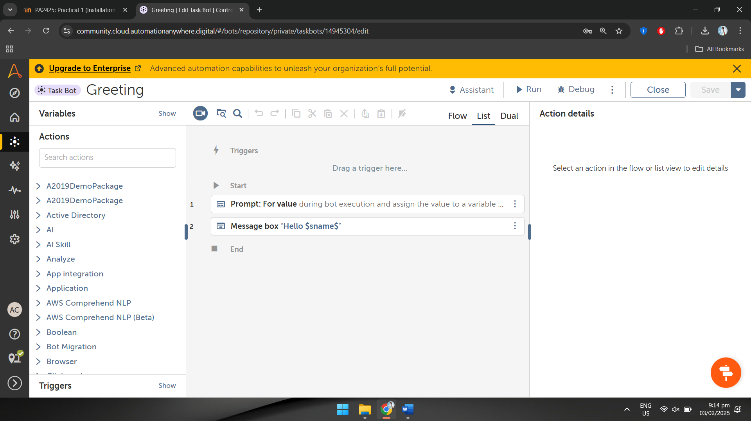

**Output:**

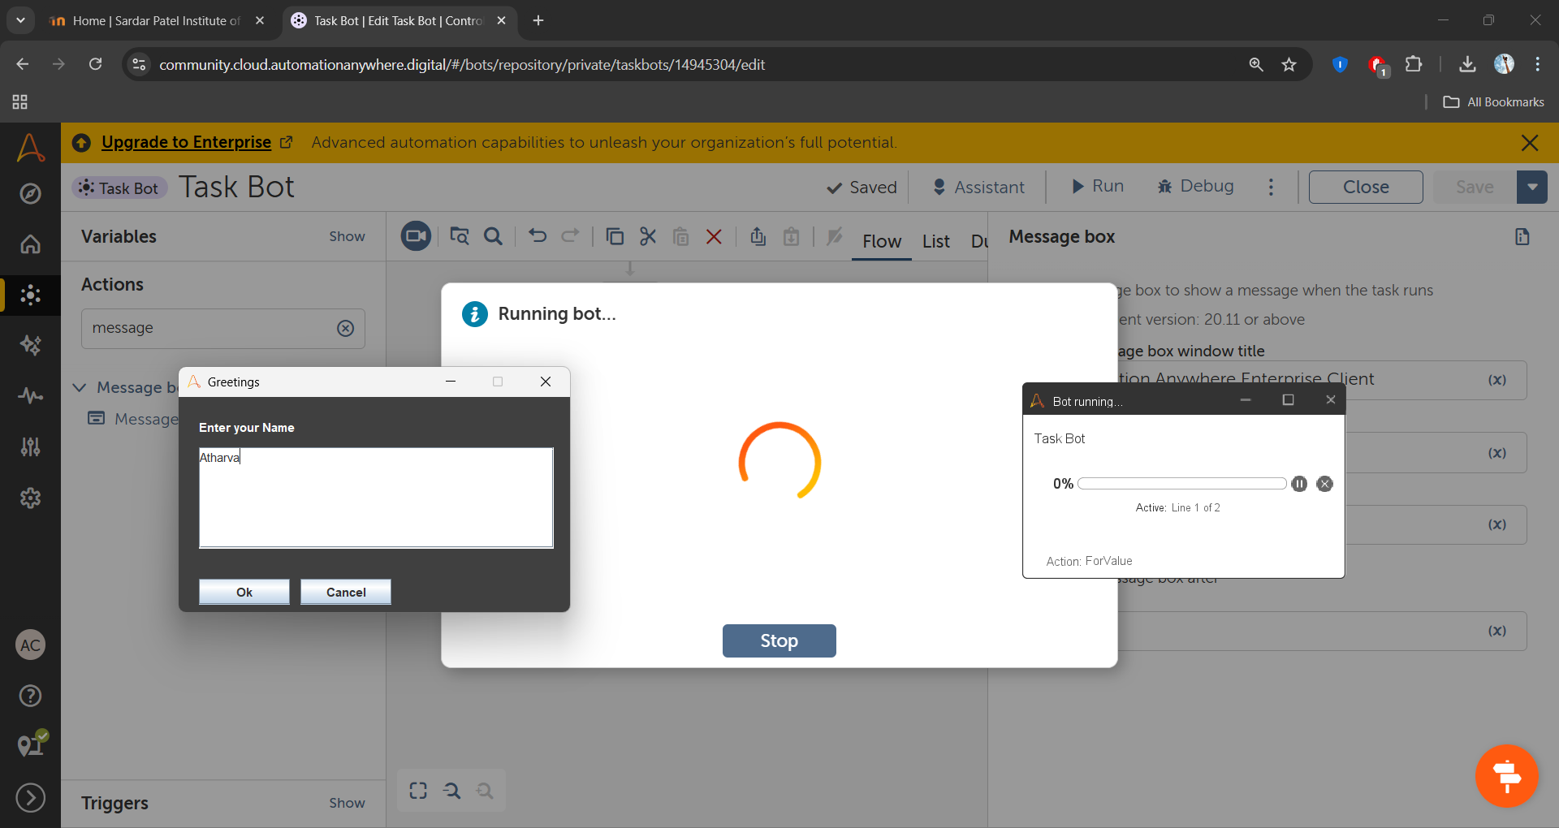

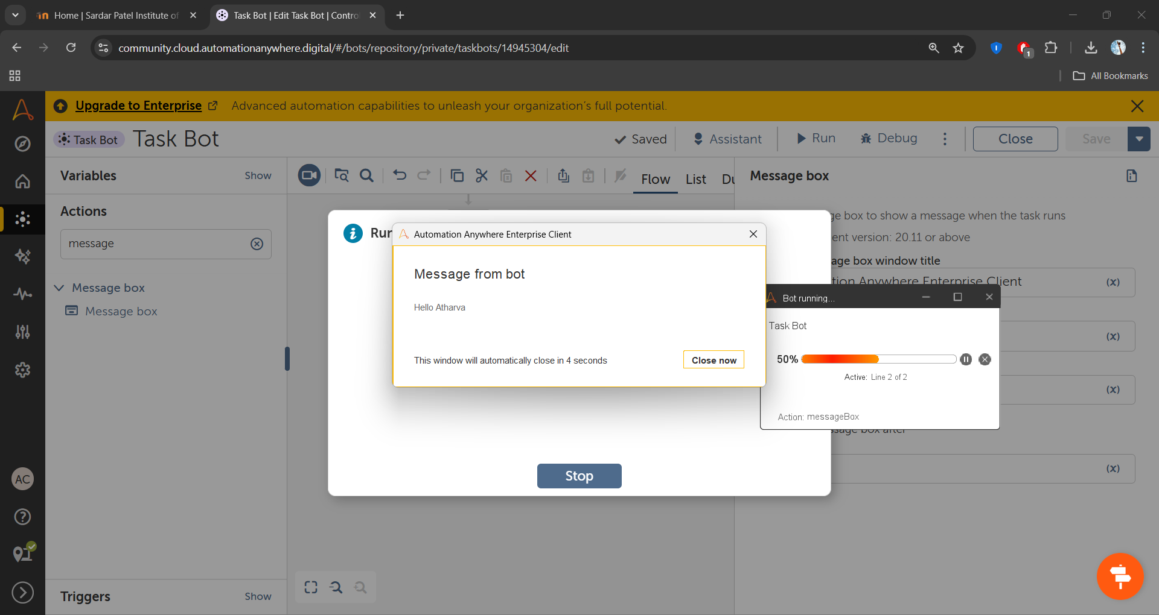

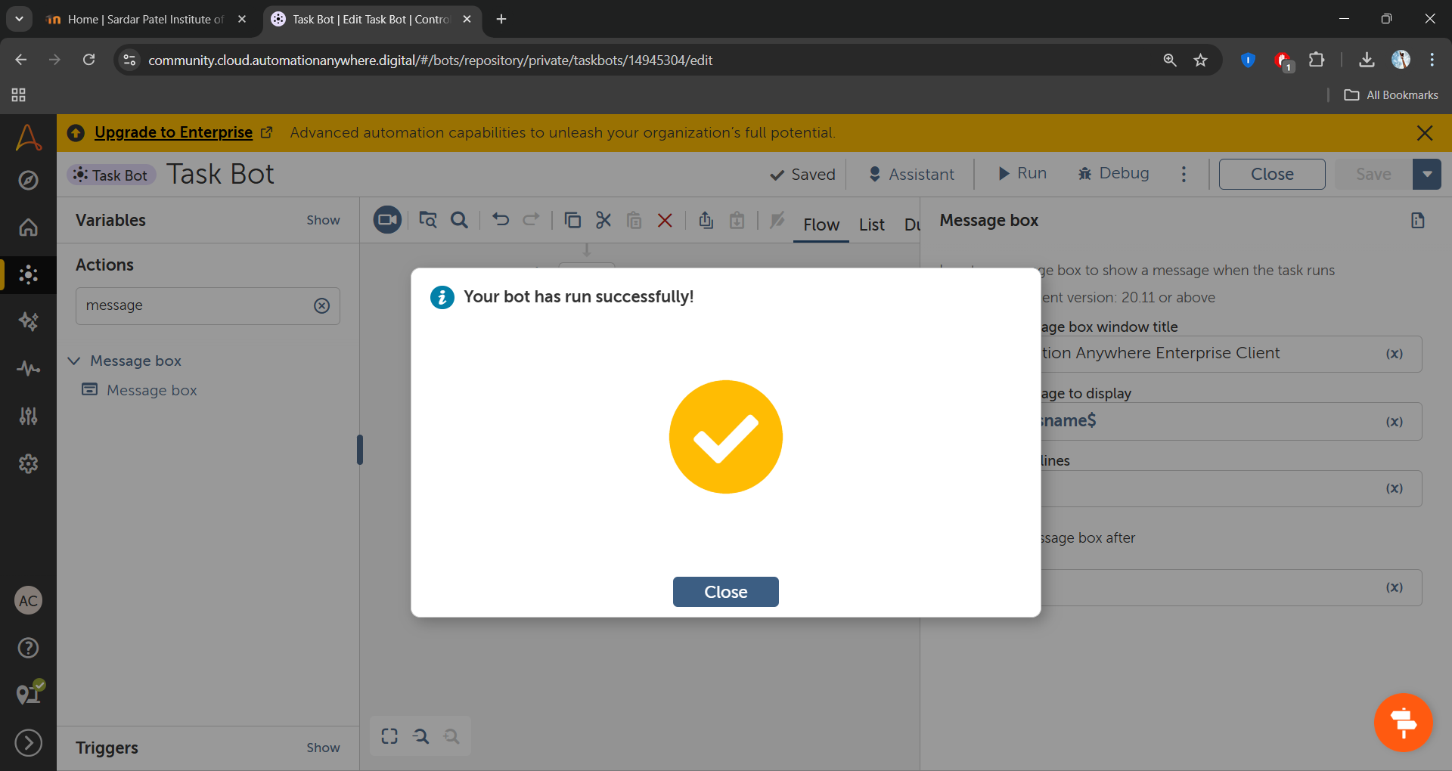

**Observation:**

A simple bot can be created using a prompt action to take user input and a message box to display the input. Automation Anywhere provides an very simple interface to design and execute bots without extensive programming knowledge.